Configure Always on

SQL server 2019

Contents

Overview 3

Prerequisites 3

Getting Started 4

Creating Cluster 4

Setting up Always On Cluster 15

# Overview

The Always On availability groups feature is a high-availability and disaster-recovery solution that provides an enterprise-level alternative to database mirroring. Introduced in SQL Server 2012 (11.x), Always On availability groups maximizes the availability of a set of user databases for an enterprise.

An availability group supports a failover environment for a discrete set of user databases, known as availability databases that fail over together. An availability group supports a set of read-write primary databases and one to eight sets of corresponding secondary databases. Optionally, secondary databases can be made available for read-only access and/or some backup operations.

# Prerequisites

* Updated Windows server for all nodes.
* Disable firewall in all replicas.
* Sql Server and Sql Server Management Studio should be installed in all the nodes.
* Floating IP and Listener IP should be predefined and ready for use for the cluster.
* In case of different network for primary and secondary/DR nodes, we need floating IP and listener IP from both network each.
* A folder in separate server which can be accessed by all the nodes is required for Quorum purpose.

**\*\* All the steps in this section is mandatory and will cause error in configuration if not followed.**

# Getting Started

# Creating Cluster

1. To create a new domain suffix, go to: ‘This pc>properties>Advanced system settings’. Select Computer name and click the ‘Change’ button then go to ‘More’ and set the DNS suffix as below and click OK:

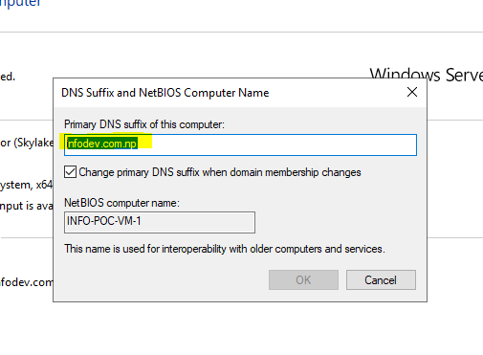

1. Search for computer management and open the app.

* Under the Local Users and Groups, click on users, right click and select new user.
* Add DBSERVICE in username and set a password.
* Check ‘Password never expires’
* Click Create

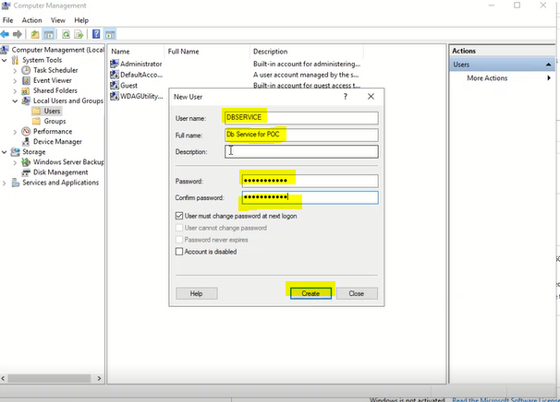

* Click on the newly created user ‘DBSERVICE’, click on the ‘Member Of’ tab and click on ‘Add ‘.

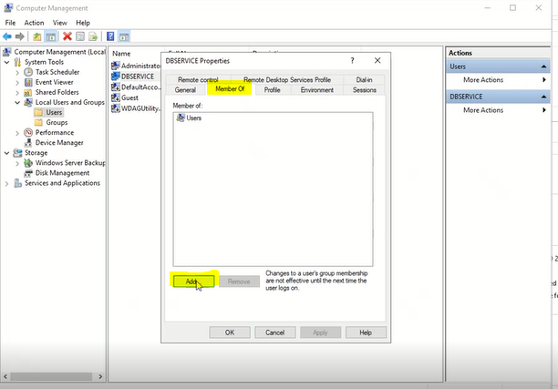

* Now, add ‘administration’ in the textbox and click OK.

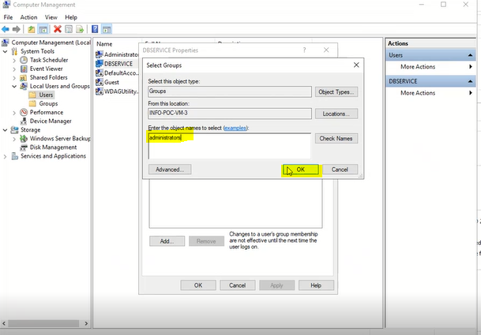

1. Go to start menu and search for ‘Server Manager’ and select it.

* Click on ‘Manage’ and click on the ‘Add Roles and Features’ from the sub menu.

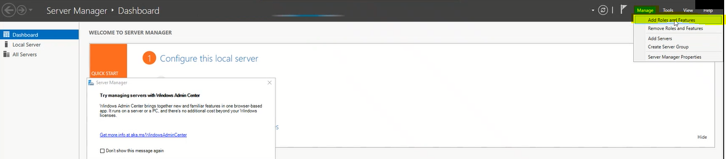

* The Add Roles and Features wizard box appears. Now click next until we reach the ‘Features’ tab.
* Now, search for ‘Failover Clustering’ and check the checkbox.

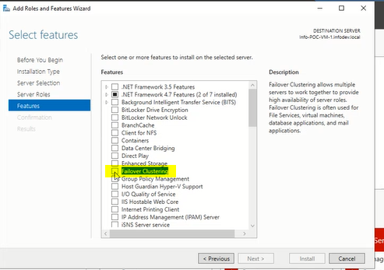

* Click on Add feature.

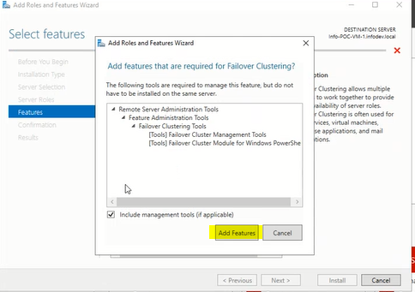

* Click next and finally, click Install.

1. Go to start menu and search for ‘Server Manager’ and select it.

* Click on ‘Tools’ then click on ‘Failover Cluster Manager’.

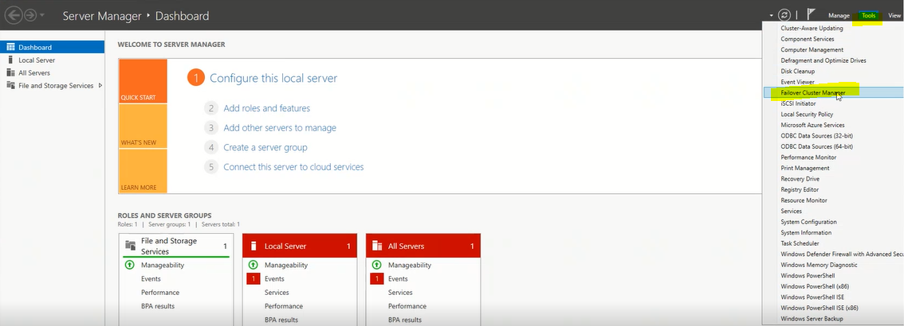

* The failover Cluster Manager box pops up. Click on the ‘Validate Configuration’ under the ‘Actions’ bar.

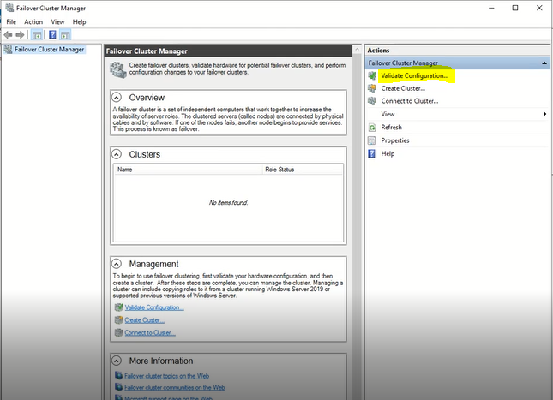

* The ‘Validate a Configuration Wizard’ appears.
* Click next and in the ‘Select Server or a cluster’ tab.
* Now, in the ‘Enter Name’ box, enter the IP of all the servers that we are adding in the cluster and click add.

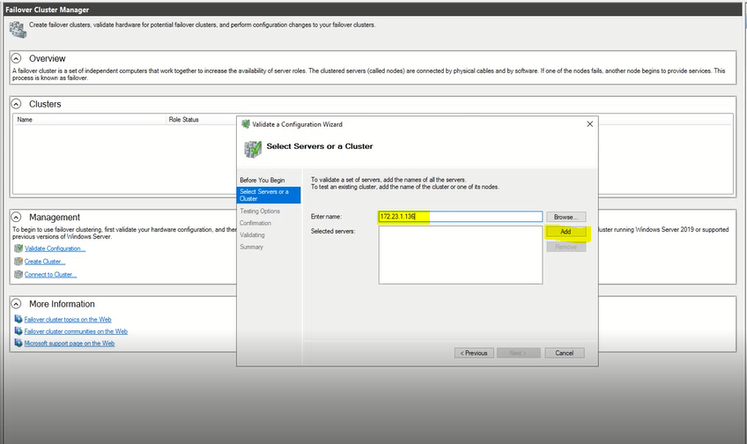

* Once all the nodes are added, click on next.

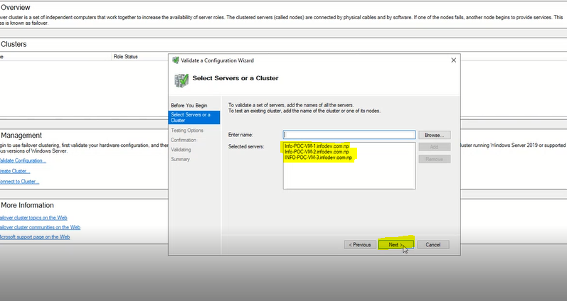

* Now, in the ‘Testing Options’ tab select the ‘Run only test I select’ option and click next.
* In the ‘Test Selection’ tab, Check the attributes as shown below diagram and click on next.

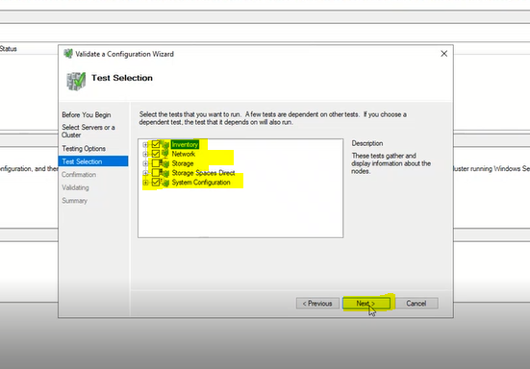

* In the ‘validating’ tab, the tests run and may take some time. To view the success and warning reports of the test, click on ‘View report’ after the test is completed. . Depending on the errors/ warning this tests returns we may need to correct the errors before moving forward.

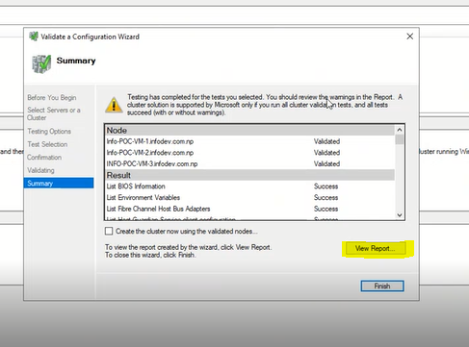

* Now check the ‘Create the cluster now using the validated nodes’ and click finish.

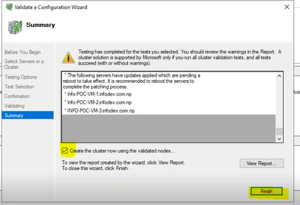

1. The ‘Create Cluster Wizard’ box appears.

* Click next until you reach the ‘Access point for administering the cluster’.
* In the ‘Cluster Name’ box, provide a name for cluster.
* In the address box, provide the Floating IP that we had decided earlier.

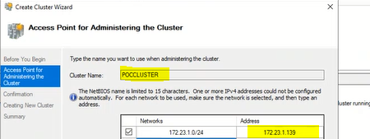

* Click next and uncheck the ‘Add all eligible storage to cluster’ and click next again.
* After the ‘Creating New Cluster’ task is completed, Click Finish.

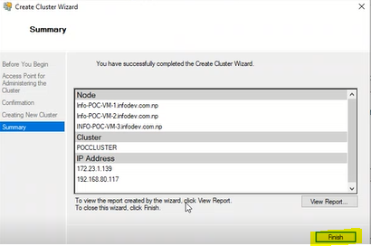

1. In the Failover Cluster Manager, we can see the cluster we created earlier.

* Right Click on the cluster name, click ‘More actions’, click ‘Configure Cluster Quorum Settings’.

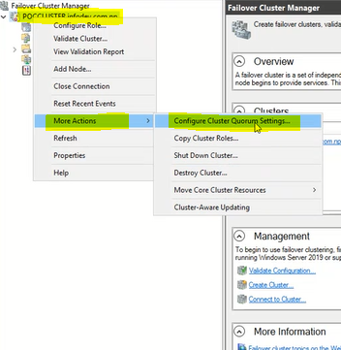

* The ‘Configure Quorum Wizard’ appears.
* Select the ‘Select the Quorum Witness’ option. Click Next.

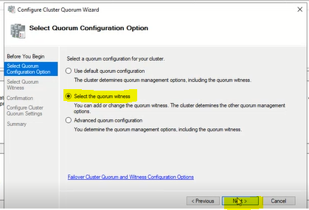

* Select the ‘Configure a file share witness’ and click next

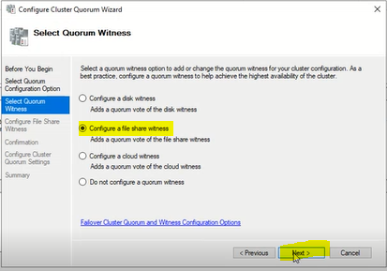

* Now provide the file location of the folder that we have allocated for Quorum purpose and click Next.

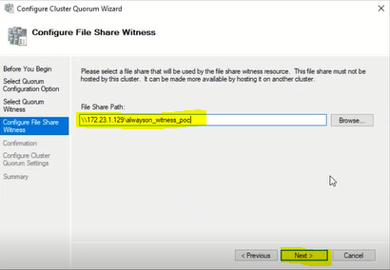

* Click next then finally click Finish.

1. Go to the file location : ‘C:\Windows\System32\drivers\etc\hosts’ and add the following line in the file and save the file:

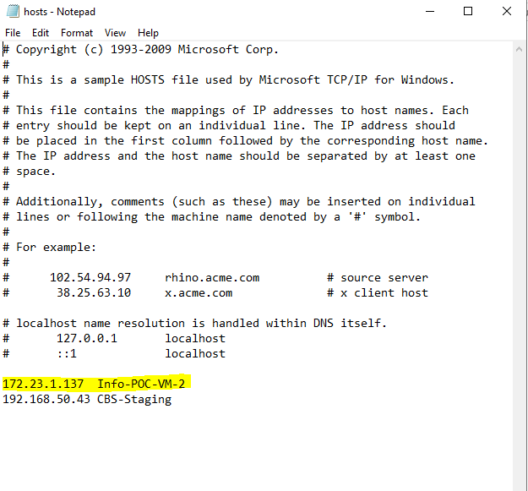

# Setting up Always On Cluster

1. Search for Sql server configuration Manager and open it.

* Select the sql server services from the menu panel.
* Double click on the sql server (instance name), the properties box then appears.
* Select the ‘Always On Availability Groups’ tab and check the ‘Enable Always on Availability Groups’ button.

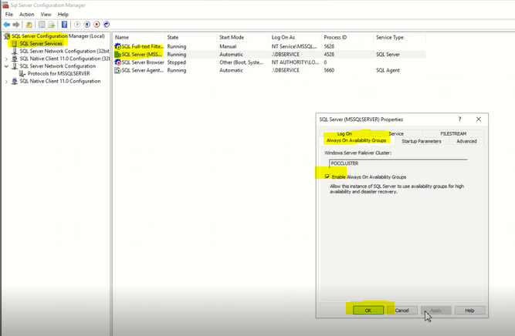

* Now click on ‘Log On’ tab and set account name as ‘.\DBSERVICE’ and set a password and click OK.

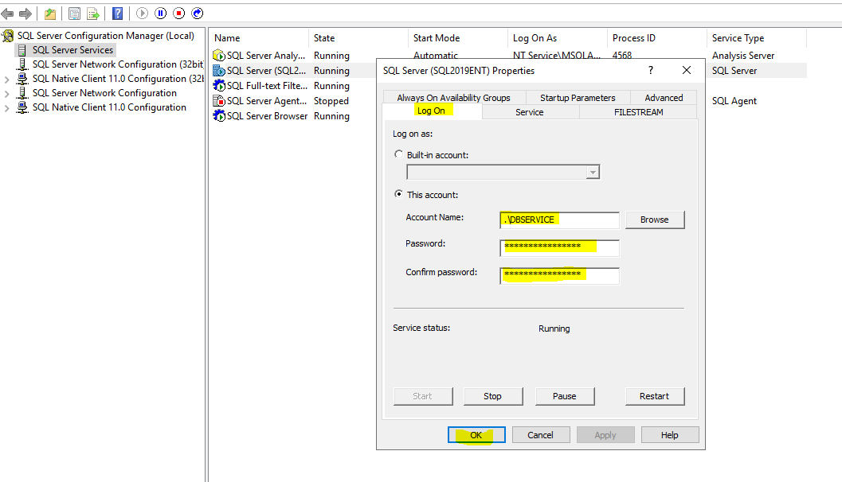

1. Open Sql Server Management Studio in the primary replica and connect to sql server instance.

* Restore all databases that we need in this availability group.
* For each database, set the Recovery mode to full.
* Take full backup of all the databases.

1. In the object explorer tab in sql server management studio

* Expand the ‘Always on High Availability’ tab.
* Then right click on ‘Availability Groups’ and select the ‘New Availability Group Wizard’.
* The ‘New Availability Group’ box then appears.
* In the ’Specify Options’ tab, provide a name in the ‘Availability group name’ and check the buttons as shown in the below image. Click next.

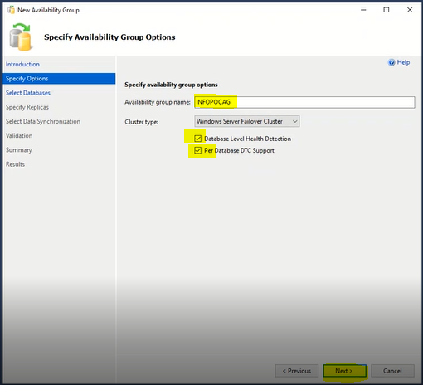

* In the ‘Select databases’ tab, select all database that we want the availability group and click next.

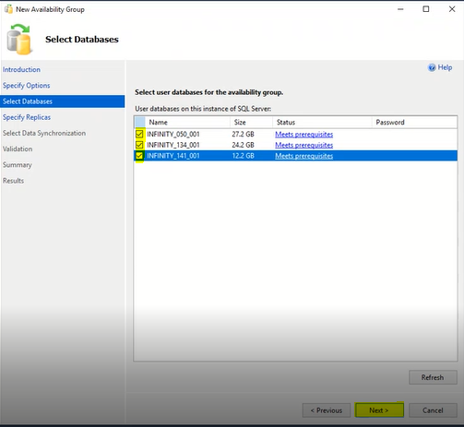

* In the ‘Specify Replicas’ tab, Click on the add replica button and provide credentials for all the secondary replicas as shown in the image below.

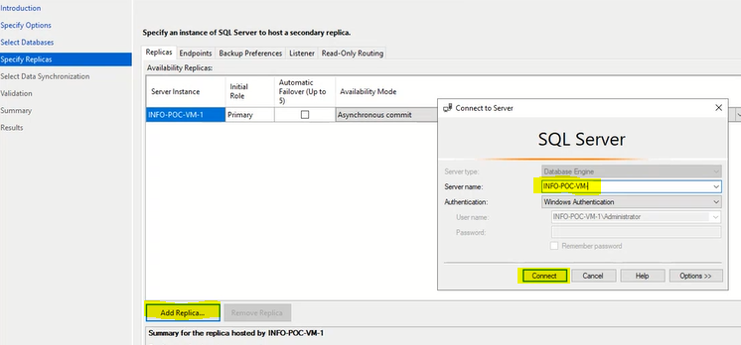

* Once all the replicas are added, change the options in the availability mode, Readable secondary and Automatic Failover as required.

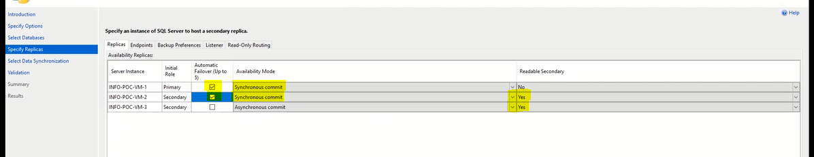

* Go to the backup preferences tab and set the backup priority for primary replica to 0.

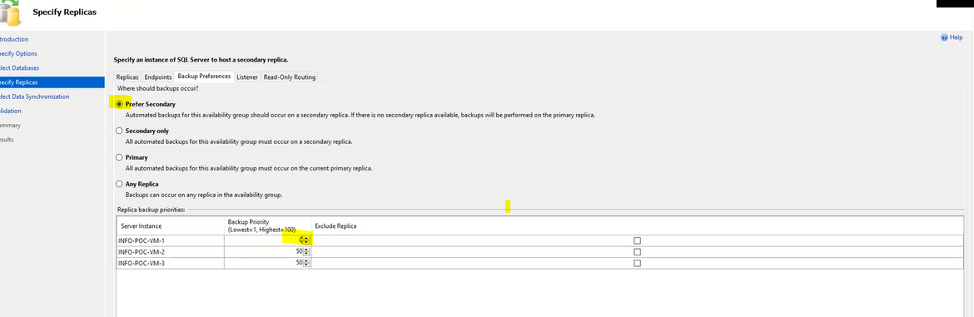

* Go to the Listener tab, and select the ‘Create the availability group listener’.
* Provide a name in the listener DNS name and set 1433 as port.
* Click on the add button on the bottom right of the box.
* In the Add IP Address box add the IP for listener that we had predefined and click ok.
* Click Next

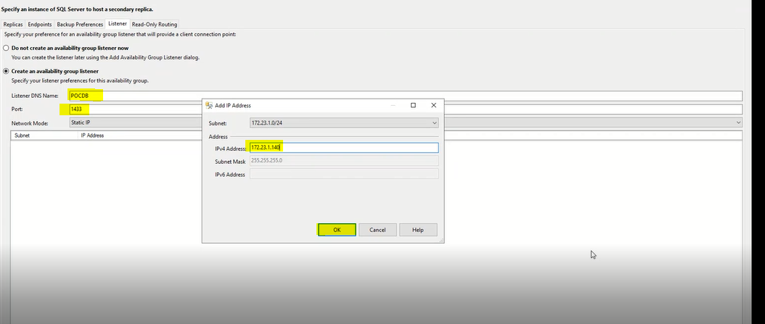

* In the ‘Select Data Synchronization’, check the ‘Automatic Seeding’ option and click next.
* Click next until we reach the ‘Summary’ screen and finally click Finish.

Once all these steps are completed, the always on availability group configuration is completed and all the database and availability group should be visible in the primary and all secondary nodes as follows.

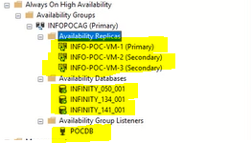

**\*\*Please note that the step 1-8 needs to be configured in all the nodes and steps 9-10 only need to be configured in the primary node.**